Librarian Information Sheet
  - Quick-reference information for recommending, shelving and discussing the book

Jamie Cooper and the Touchscreen Portal | The Gateway Saga - Book One | J P Harper
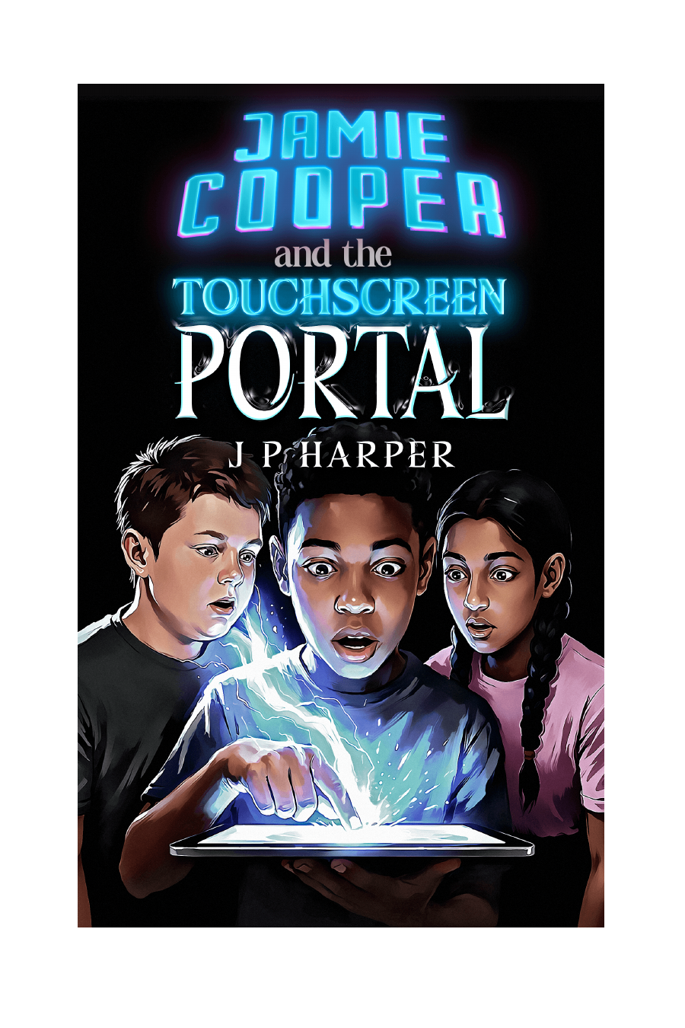 | AT A GLANCE  Title: Jamie Cooper and the Touchscreen Portal  Author: J P Harper  Series: The Gateway Saga - Book One  Recommended readers: Ages 9-14  Genre: Middle-grade portal fantasy with a science-fiction twist and light game-like elements  Structure: 20 chapters; approximately 350 pages, depending on edition  Publisher: Creative-Sparx Press  First published: Great Britain, 2026

Why it may work well in a library
- A fast-moving hidden-world adventure built around portals, maps, magical abilities, quests and a central mystery.
- Game-like discovery without heavy statistics or rule exposition, making it accessible to readers who like gaming but do not necessarily want full LitRPG.
- Three ordinary classmates become a complementary team, creating strong discussion material around friendship, first impressions, courage and belonging.
- The mystery of Jamie's missing brother provides a continuing emotional thread beneath the action.
- Book One opens a wider series while still offering a substantial adventure and clear character development.

Reader fit
May especially appeal to readers who enjoy... | Adult recommendation notes
Portals, hidden worlds and maps | The story begins in an ordinary school/home setting before expanding into Myridiam.
Fantasy quests and magical powers | The trio gain distinct roles and artefacts, but teamwork and judgement remain important.
Video games and game-like discovery | Gaming influences Jamie's expectations, but the story questions whether Myridiam is a game at all.
Mystery and cliff-hanger questions | Cameron, 2126, the Gateway and the northern threat provide continuing mysteries.
Friendship and unlikely heroes | Jamie, Dan and Lakshmi each feel underestimated in different ways.

Content and sensitivity overview
Contains grief connected to a missing older brother, strained family communication, school bullying, an intimidating parent affected by alcohol, fantasy battles, injuries, burning buildings, abduction and threats of war. Violence is adventurous rather than graphic, but some readers may benefit from advance notice.

Library / catalogue identifiers
Format / identifier | Code | Notes
Ebook ASIN | B0H2KWNDTH | Amazon ebook identifier
Paperback ISBN-10 | 1067601406 | Also used as the print Amazon identifier
Paperback ISBN-13 | 9781067601409 | 13-digit conversion of the ISBN-10
Hardback ISBN-10 | 1067601414 | Also used as the print Amazon identifier
Hardback ISBN-13 | 9781067601416 | 13-digit conversion of the ISBN-10

Quick hand-sell
30-second recommendation
Try this if you like portals, quests, maps and game-like discovery. Jamie's tablet opens a Gateway into Myridiam, where he and two classmates gain unusual abilities and become caught in a conflict that may be connected to his missing brother.

Useful links for adults
- Author and book information: www.jpharper.com
- Free Gateway Preview Pack: portal.jpharper.com
- Additional educator and librarian materials can be offered alongside this sheet as they become available.

