Vocabulary Workbook
  - Forty words from the novel, organised into five reading units with practice activities

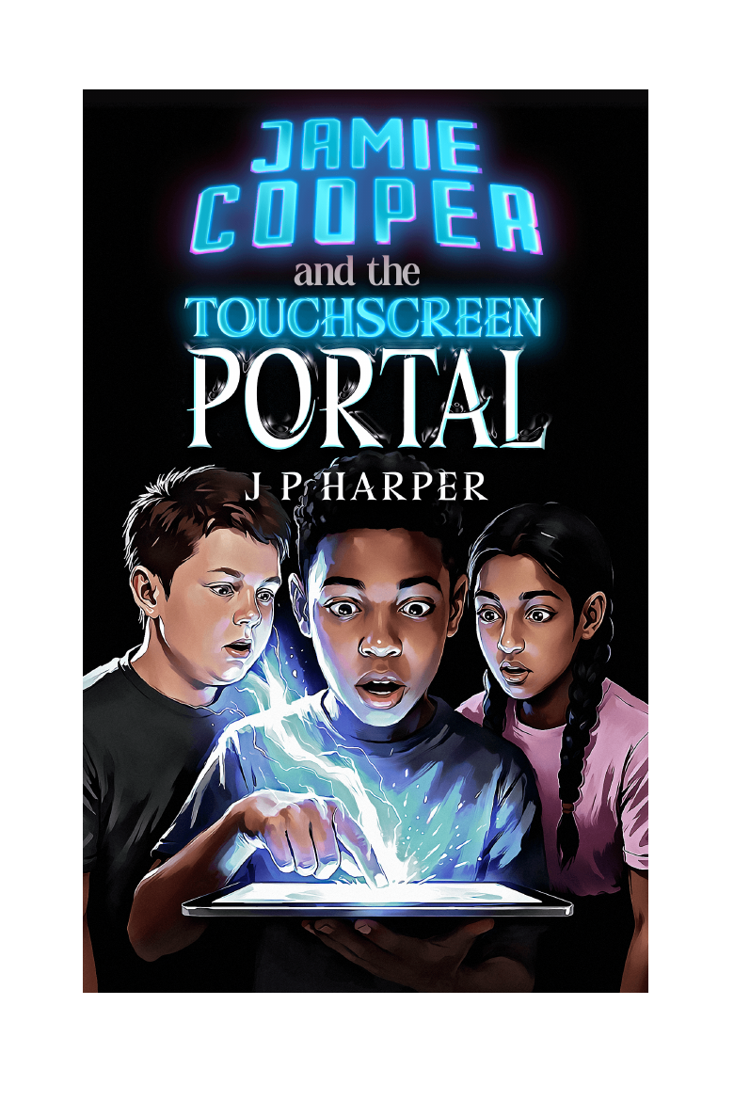
Jamie Cooper and the Touchscreen Portal | The Gateway Saga - Book One | J P Harper

How to use this workbook
Complete each unit after reading the named chapters. Definitions are written for learners aged 9-14. The final pages provide answers to the matching and sentence-completion activities.

Unit 1 - Chapters 1-4: Ordinary life and the Gateway

Name: __________________________ | Class/group: __________________ | Date: __________________

Word bank
Word | Meaning | Word class
terraced | built as one of a row of joined houses | adjective
insistent | continuing firmly and demanding attention | adjective
fragments | small broken pieces or incomplete parts | noun
precision | exactness and careful accuracy | noun
dismissal | the act of sending something away or treating it as unimportant | noun
outsider | a person who does not feel accepted as part of a group | noun
intricate | containing many small and carefully arranged details | adjective
symmetry | balanced matching of shape or arrangement on opposite sides | noun

Activity A - Match the meaning
Write the correct word beside each definition. Use every word once.
A. exactness and careful accuracy ______________________________
B. containing many small and carefully arranged details ______________________________
C. continuing firmly and demanding attention ______________________________
D. balanced matching of shape or arrangement on opposite sides ______________________________
E. built as one of a row of joined houses ______________________________
F. a person who does not feel accepted as part of a group ______________________________
G. small broken pieces or incomplete parts ______________________________
H. the act of sending something away or treating it as unimportant ______________________________

Activity B - Complete the sentences
Word bank: terraced, insistent, fragments, precision, dismissal, outsider, intricate, symmetry
1. The houses formed a __________ row with no gaps between them.
2. The message became more __________ each time it appeared.
3. Jamie remembered the day in scattered __________ rather than as one complete picture.
4. Lakshmi copied the pattern with great __________.
5. Jamie recognised his father's gentle __________ and stopped asking questions.
6. At the new school, Jamie felt like an __________ watching everyone else.
7. The Gateway symbol was too __________ to be a casual doodle.
8. The pattern's perfect __________ made it look deliberately designed.

Activity C - Work with the words
Choose one adjective from the unit and write a synonym: ______________________________
____________________________________________________________________________________________
Choose one noun from the unit and write a sentence that shows its meaning: ______________________________
____________________________________________________________________________________________
Which word would be most useful when describing danger or tension? Explain: ______________________________
____________________________________________________________________________________________
Which word was least familiar to you before this unit? Write a memory clue for it: ______________________________
____________________________________________________________________________________________

Activity D - Short writing challenge
Write a short paragraph connected to the chapters and use at least four unit words accurately. Underline the four words.
____________________________________________________________________________________________
____________________________________________________________________________________________
____________________________________________________________________________________________
____________________________________________________________________________________________
____________________________________________________________________________________________
____________________________________________________________________________________________

Unit 2 - Chapters 5-8: Myridiam and its dangers

Name: __________________________ | Class/group: __________________ | Date: __________________

Word bank
Word | Meaning | Word class
reclusive | avoiding other people and preferring to live privately | adjective
conviction | a strong belief that something is true | noun
translucent | allowing some light through but not completely clear | adjective
artefact | an object made or shaped by people, often with cultural or historical importance | noun
monument | a structure or object that preserves memory or marks importance | noun
hostile | unfriendly, threatening or ready to attack | adjective
inexorable | impossible to stop or prevent | adjective
peripheral | at the outer edge rather than the centre | adjective

Activity A - Match the meaning
Write the correct word beside each definition. Use every word once.
A. an object made or shaped by people, often with cultural or historical importance ______________________________
B. impossible to stop or prevent ______________________________
C. a strong belief that something is true ______________________________
D. at the outer edge rather than the centre ______________________________
E. avoiding other people and preferring to live privately ______________________________
F. unfriendly, threatening or ready to attack ______________________________
G. allowing some light through but not completely clear ______________________________
H. a structure or object that preserves memory or marks importance ______________________________

Activity B - Complete the sentences
Word bank: reclusive, conviction, translucent, artefact, monument, hostile, inexorable, peripheral
1. The Avirans were described as __________ and rarely seen beyond their mountains.
2. Jamie spoke with enough __________ that Sathyra began to believe him.
3. His hand became __________ as the Gateway pulled him home.
4. The bow appeared to be an ancient magical __________.
5. The carved stone __________ linked Myridiam to Cameron's notes.
6. The game-like text identified the Mire Grim as __________.
7. The creature kept advancing with an __________ force.
8. Jamie noticed information appearing in his __________ vision.

Activity C - Work with the words
Choose one adjective from the unit and write a synonym: ______________________________
____________________________________________________________________________________________
Choose one noun from the unit and write a sentence that shows its meaning: ______________________________
____________________________________________________________________________________________
Which word would be most useful when describing danger or tension? Explain: ______________________________
____________________________________________________________________________________________
Which word was least familiar to you before this unit? Write a memory clue for it: ______________________________
____________________________________________________________________________________________

Activity D - Short writing challenge
Write a short paragraph connected to the chapters and use at least four unit words accurately. Underline the four words.
____________________________________________________________________________________________
____________________________________________________________________________________________
____________________________________________________________________________________________
____________________________________________________________________________________________
____________________________________________________________________________________________
____________________________________________________________________________________________

Unit 3 - Chapters 9-12: New players and conflict

Name: __________________________ | Class/group: __________________ | Date: __________________

Word bank
Word | Meaning | Word class
methodical | done in an organised and systematic way | adjective
palpable | so strong or obvious that it seems almost touchable | adjective
scepticism | doubt about whether something is true or reliable | noun
mandala | a circular symbolic design used in several cultural and spiritual traditions | noun
vulnerable | open to harm, attack or emotional hurt | adjective
resolute | firmly determined and unwilling to give up | adjective
confrontation | a direct and often tense meeting or conflict | noun
strategy | a planned approach for achieving a goal | noun

Activity A - Match the meaning
Write the correct word beside each definition. Use every word once.
A. a circular symbolic design used in several cultural and spiritual traditions ______________________________
B. a direct and often tense meeting or conflict ______________________________
C. so strong or obvious that it seems almost touchable ______________________________
D. a planned approach for achieving a goal ______________________________
E. done in an organised and systematic way ______________________________
F. firmly determined and unwilling to give up ______________________________
G. doubt about whether something is true or reliable ______________________________
H. open to harm, attack or emotional hurt ______________________________

Activity B - Complete the sentences
Word bank: methodical, palpable, scepticism, mandala, vulnerable, resolute, confrontation, strategy
1. Dan searched the stockroom in a quiet, __________ way.
2. His excitement was __________ once the map appeared.
3. Lakshmi's __________ made her test the boys' claims carefully.
4. She said the circular symbol resembled a __________.
5. Families fleeing the burning village were especially __________.
6. Sathyra remained __________ even after seeing the damage to Clearwater.
7. A misunderstanding nearly caused a dangerous __________ at the border.
8. The pursuit needed a better __________ than simply following the trail.

Activity C - Work with the words
Choose one adjective from the unit and write a synonym: ______________________________
____________________________________________________________________________________________
Choose one noun from the unit and write a sentence that shows its meaning: ______________________________
____________________________________________________________________________________________
Which word would be most useful when describing danger or tension? Explain: ______________________________
____________________________________________________________________________________________
Which word was least familiar to you before this unit? Write a memory clue for it: ______________________________
____________________________________________________________________________________________

Activity D - Short writing challenge
Write a short paragraph connected to the chapters and use at least four unit words accurately. Underline the four words.
____________________________________________________________________________________________
____________________________________________________________________________________________
____________________________________________________________________________________________
____________________________________________________________________________________________
____________________________________________________________________________________________
____________________________________________________________________________________________

Unit 4 - Chapters 13-16: Planning and pursuit

Name: __________________________ | Class/group: __________________ | Date: __________________

Word bank
Word | Meaning | Word class
uncertainty | a state of not knowing what is true or what will happen | noun
responsibility | a duty to act carefully and answer for one's decisions | noun
tactical | connected with practical plans used to achieve an immediate aim | adjective
relentless | continuing without becoming weaker or stopping | adjective
treacherous | dangerous and difficult to trust or travel across | adjective
territory | land controlled or occupied by a particular people or group | noun
improvised | made or arranged quickly from what is available | adjective
suspicion | a feeling that something may be wrong or dishonest | noun

Activity A - Match the meaning
Write the correct word beside each definition. Use every word once.
A. continuing without becoming weaker or stopping ______________________________
B. made or arranged quickly from what is available ______________________________
C. a duty to act carefully and answer for one's decisions ______________________________
D. a feeling that something may be wrong or dishonest ______________________________
E. a state of not knowing what is true or what will happen ______________________________
F. land controlled or occupied by a particular people or group ______________________________
G. connected with practical plans used to achieve an immediate aim ______________________________
H. dangerous and difficult to trust or travel across ______________________________

Activity B - Complete the sentences
Word bank: uncertainty, responsibility, tactical, relentless, treacherous, territory, improvised, suspicion
1. The one-way messages left Jamie with growing __________.
2. Power brought the trio a new __________ to protect others.
3. Lakshmi's __________ thinking helped the group compare raid patterns.
4. The pursuit was __________, allowing little time for recovery.
5. Loose rock made the mountain route __________.
6. The travellers needed permission before crossing Sothian __________.
7. Discarded straps suggested the raiders had used __________ bindings.
8. Signs along the route increased the group's __________ that they were being led into danger.

Activity C - Work with the words
Choose one adjective from the unit and write a synonym: ______________________________
____________________________________________________________________________________________
Choose one noun from the unit and write a sentence that shows its meaning: ______________________________
____________________________________________________________________________________________
Which word would be most useful when describing danger or tension? Explain: ______________________________
____________________________________________________________________________________________
Which word was least familiar to you before this unit? Write a memory clue for it: ______________________________
____________________________________________________________________________________________

Activity D - Short writing challenge
Write a short paragraph connected to the chapters and use at least four unit words accurately. Underline the four words.
____________________________________________________________________________________________
____________________________________________________________________________________________
____________________________________________________________________________________________
____________________________________________________________________________________________
____________________________________________________________________________________________
____________________________________________________________________________________________

Unit 5 - Chapters 17-20: Battle, alliance and aftermath

Name: __________________________ | Class/group: __________________ | Date: __________________

Word bank
Word | Meaning | Word class
ravine | a deep, narrow valley with steep sides | noun
plateau | an area of high, mostly level ground | noun
reinforcements | additional people or supplies sent to strengthen a group | noun
aftermath | the period and consequences following a destructive event | noun
formidable | very powerful, difficult or impressive | adjective
consequence | a result that follows from an action or event | noun
alliance | a partnership formed for mutual support or a shared purpose | noun
endurance | the ability to continue through difficulty, pain or tiredness | noun

Activity A - Match the meaning
Write the correct word beside each definition. Use every word once.
A. the period and consequences following a destructive event ______________________________
B. a partnership formed for mutual support or a shared purpose ______________________________
C. an area of high, mostly level ground ______________________________
D. the ability to continue through difficulty, pain or tiredness ______________________________
E. a deep, narrow valley with steep sides ______________________________
F. a result that follows from an action or event ______________________________
G. additional people or supplies sent to strengthen a group ______________________________
H. very powerful, difficult or impressive ______________________________

Activity B - Complete the sentences
Word bank: ravine, plateau, reinforcements, aftermath, formidable, consequence, alliance, endurance
1. The champion waited in the narrow __________.
2. Greyfang Ridge stood on a natural __________ above the surrounding land.
3. The coalition stopped to gather supplies and __________.
4. In the __________ of battle, the wounded needed immediate care.
5. The fortress walls looked old but still __________.
6. The lost Heart Stone could have a serious __________ for Clearwater.
7. Shared danger created an __________ between Khitari and Sothians.
8. Dan survived the fight through protection, timing and __________.

Activity C - Work with the words
Choose one adjective from the unit and write a synonym: ______________________________
____________________________________________________________________________________________
Choose one noun from the unit and write a sentence that shows its meaning: ______________________________
____________________________________________________________________________________________
Which word would be most useful when describing danger or tension? Explain: ______________________________
____________________________________________________________________________________________
Which word was least familiar to you before this unit? Write a memory clue for it: ______________________________
____________________________________________________________________________________________

Activity D - Short writing challenge
Write a short paragraph connected to the chapters and use at least four unit words accurately. Underline the four words.
____________________________________________________________________________________________
____________________________________________________________________________________________
____________________________________________________________________________________________
____________________________________________________________________________________________
____________________________________________________________________________________________
____________________________________________________________________________________________

My personal Myridiam glossary
Add unfamiliar or interesting words that you notice while reading. Use context first, then check a dictionary or ask an adult.
Word | Chapter/page | My first guess | Checked meaning | My own sentence

Answer guide

Unit 1 - Chapters 1-4: Ordinary life and the Gateway
Activity A: A - precision; B - intricate; C - insistent; D - symmetry; E - terraced; F - outsider; G - fragments; H - dismissal
Activity B: 1 - terraced; 2 - insistent; 3 - fragments; 4 - precision; 5 - dismissal; 6 - outsider; 7 - intricate; 8 - symmetry
Activities C and D are open-ended. Credit accurate meaning, suitable grammar and clear context.

Unit 2 - Chapters 5-8: Myridiam and its dangers
Activity A: A - artefact; B - inexorable; C - conviction; D - peripheral; E - reclusive; F - hostile; G - translucent; H - monument
Activity B: 1 - reclusive; 2 - conviction; 3 - translucent; 4 - artefact; 5 - monument; 6 - hostile; 7 - inexorable; 8 - peripheral
Activities C and D are open-ended. Credit accurate meaning, suitable grammar and clear context.

Unit 3 - Chapters 9-12: New players and conflict
Activity A: A - mandala; B - confrontation; C - palpable; D - strategy; E - methodical; F - resolute; G - scepticism; H - vulnerable
Activity B: 1 - methodical; 2 - palpable; 3 - scepticism; 4 - mandala; 5 - vulnerable; 6 - resolute; 7 - confrontation; 8 - strategy
Activities C and D are open-ended. Credit accurate meaning, suitable grammar and clear context.

Unit 4 - Chapters 13-16: Planning and pursuit
Activity A: A - relentless; B - improvised; C - responsibility; D - suspicion; E - uncertainty; F - territory; G - tactical; H - treacherous
Activity B: 1 - uncertainty; 2 - responsibility; 3 - tactical; 4 - relentless; 5 - treacherous; 6 - territory; 7 - improvised; 8 - suspicion
Activities C and D are open-ended. Credit accurate meaning, suitable grammar and clear context.

Unit 5 - Chapters 17-20: Battle, alliance and aftermath
Activity A: A - aftermath; B - alliance; C - plateau; D - endurance; E - ravine; F - consequence; G - reinforcements; H - formidable
Activity B: 1 - ravine; 2 - plateau; 3 - reinforcements; 4 - aftermath; 5 - formidable; 6 - consequence; 7 - alliance; 8 - endurance
Activities C and D are open-ended. Credit accurate meaning, suitable grammar and clear context.

