Reading Comprehension Worksheets
  - Five whole-section worksheets with recall, inference, author-craft and extended-response questions

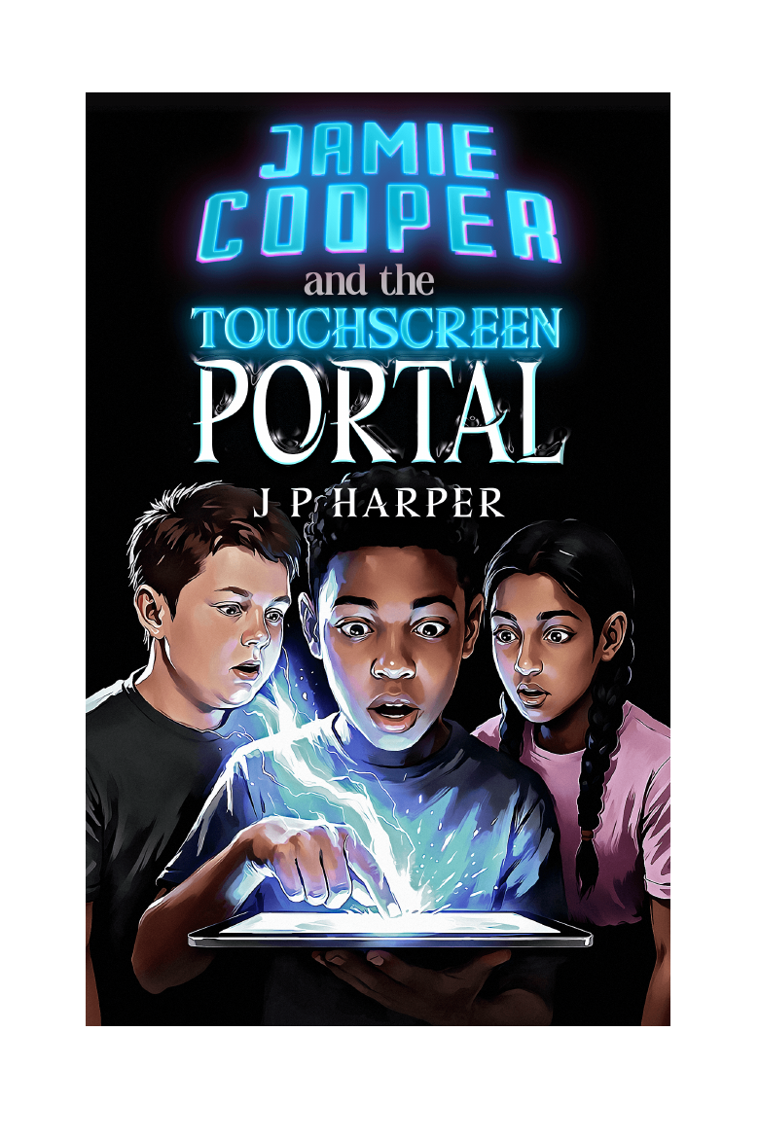
Jamie Cooper and the Touchscreen Portal | The Gateway Saga - Book One | J P Harper

Spoiler guidance
Each worksheet covers four completed chapters. The teacher answer guide at the back contains spoilers and may be removed before distributing student pages.

Worksheet 1 - From Silence to the Gateway
  - Chapters 1-4

Name: __________________________ | Class/group: __________________ | Date: __________________

Recall
1. Why have Jamie and his father moved away from London?
____________________________________________________________________________________________
____________________________________________________________________________________________
2. What object belonging to Cameron does Jamie find, and what is inside it?
____________________________________________________________________________________________
____________________________________________________________________________________________
3. How does Lakshmi help Jamie on his first day at Briarwood Academy?
____________________________________________________________________________________________
____________________________________________________________________________________________
4. What three ideas are repeated in the tablet messages before Jamie crosses the Gateway?
____________________________________________________________________________________________
____________________________________________________________________________________________

Inference
5. Why does Jamie repeatedly describe things as “fine” when they clearly are not?
____________________________________________________________________________________________
____________________________________________________________________________________________
____________________________________________________________________________________________
6. What makes Jamie willing to believe that the unknown sender may genuinely need help?
____________________________________________________________________________________________
____________________________________________________________________________________________
____________________________________________________________________________________________
7. How does the author encourage the reader to question whether Dan deserves his reputation?
____________________________________________________________________________________________
____________________________________________________________________________________________
____________________________________________________________________________________________

Author's craft
8. Explain how the repeated use of silence creates mood in the opening chapter.
____________________________________________________________________________________________
____________________________________________________________________________________________
____________________________________________________________________________________________
9. Identify two sensory details from Jamie's arrival in Myridiam and explain their effect.
____________________________________________________________________________________________
____________________________________________________________________________________________
____________________________________________________________________________________________

Extended response
10. Was Jamie right to activate the Gateway without telling an adult? Give a balanced answer using evidence from the story.
____________________________________________________________________________________________
____________________________________________________________________________________________
____________________________________________________________________________________________
____________________________________________________________________________________________
____________________________________________________________________________________________
____________________________________________________________________________________________

Worksheet 2 - Allies, Clues and Consequences
  - Chapters 5-8

Name: __________________________ | Class/group: __________________ | Date: __________________

Recall
1. Who is Sathyra, and why is she initially cautious around Jamie?
____________________________________________________________________________________________
____________________________________________________________________________________________
2. What are the four great peoples of Myridiam named by Sathyra?
____________________________________________________________________________________________
____________________________________________________________________________________________
3. How does Jamie help Dan during the History lesson?
____________________________________________________________________________________________
____________________________________________________________________________________________
4. What does Jamie discover on the ancient monument in the forest?
____________________________________________________________________________________________
____________________________________________________________________________________________

Inference
5. Why is Sathyra eventually willing to guide Jamie to Clearwater?
____________________________________________________________________________________________
____________________________________________________________________________________________
____________________________________________________________________________________________
6. What does Dan's response to the older boys reveal about the difference between strength and aggression?
____________________________________________________________________________________________
____________________________________________________________________________________________
____________________________________________________________________________________________
7. Why does Jamie return to Myridiam sooner than he planned?
____________________________________________________________________________________________
____________________________________________________________________________________________
____________________________________________________________________________________________

Author's craft
8. How does the author use the contrast between the real world and Myridiam to show Jamie's emotional needs?
____________________________________________________________________________________________
____________________________________________________________________________________________
____________________________________________________________________________________________
9. Why is the Mire Grim encounter important beyond providing action?
____________________________________________________________________________________________
____________________________________________________________________________________________
____________________________________________________________________________________________

Extended response
10. Which clue provides the strongest evidence that Cameron may have entered Myridiam? Explain why.
____________________________________________________________________________________________
____________________________________________________________________________________________
____________________________________________________________________________________________
____________________________________________________________________________________________
____________________________________________________________________________________________
____________________________________________________________________________________________

Worksheet 3 - New Players and the Attack on Clearwater
  - Chapters 9-12

Name: __________________________ | Class/group: __________________ | Date: __________________

Recall
1. What accidental event causes the holographic map to appear?
____________________________________________________________________________________________
____________________________________________________________________________________________
2. How does Lakshmi interpret the circular symbol when she studies it?
____________________________________________________________________________________________
____________________________________________________________________________________________
3. Which roles or artefacts are associated with Jamie, Dan and Lakshmi?
____________________________________________________________________________________________
____________________________________________________________________________________________
4. What do the Reptoids take from Clearwater?
____________________________________________________________________________________________
____________________________________________________________________________________________

Inference
5. Why does Dan accept Jamie's story more quickly than Lakshmi?
____________________________________________________________________________________________
____________________________________________________________________________________________
____________________________________________________________________________________________
6. What evidence suggests the attack on Clearwater is organised rather than random?
____________________________________________________________________________________________
____________________________________________________________________________________________
____________________________________________________________________________________________
7. Why do the three children choose to run towards the village cries?
____________________________________________________________________________________________
____________________________________________________________________________________________
____________________________________________________________________________________________

Author's craft
8. How does the change from weapon practice to real danger alter the mood at the end of Chapter Ten?
____________________________________________________________________________________________
____________________________________________________________________________________________
____________________________________________________________________________________________
9. How are civilians used to show the consequences of the attack?
____________________________________________________________________________________________
____________________________________________________________________________________________
____________________________________________________________________________________________

Extended response
10. Should the group pursue the raiders immediately or remain to defend Clearwater? Present both sides before deciding.
____________________________________________________________________________________________
____________________________________________________________________________________________
____________________________________________________________________________________________
____________________________________________________________________________________________
____________________________________________________________________________________________
____________________________________________________________________________________________

Worksheet 4 - Plans, Priorities and the Broken Pass
  - Chapters 13-16

Name: __________________________ | Class/group: __________________ | Date: __________________

Recall
1. What does Lakshmi do as soon as the trio return to the shop?
____________________________________________________________________________________________
____________________________________________________________________________________________
2. What phrase from 2126 makes Jamie feel watched?
____________________________________________________________________________________________
____________________________________________________________________________________________
3. Why do the friends consider entering Myridiam separately?
____________________________________________________________________________________________
____________________________________________________________________________________________
4. What type of settlement does Jamie reach in Chapter Fifteen?
____________________________________________________________________________________________
____________________________________________________________________________________________

Inference
5. Why does recording abilities and events help the group?
____________________________________________________________________________________________
____________________________________________________________________________________________
____________________________________________________________________________________________
6. What could go wrong when friends enter a dangerous world separately?
____________________________________________________________________________________________
____________________________________________________________________________________________
____________________________________________________________________________________________
7. How does helping at Oakhill demonstrate Jamie's development?
____________________________________________________________________________________________
____________________________________________________________________________________________
____________________________________________________________________________________________

Author's craft
8. How does the author use route, terrain and narrowing spaces to build tension in the broken pass?
____________________________________________________________________________________________
____________________________________________________________________________________________
____________________________________________________________________________________________
9. Why are unanswered messages from 2126 more unsettling than an ordinary conversation?
____________________________________________________________________________________________
____________________________________________________________________________________________
____________________________________________________________________________________________

Extended response
10. Is dividing the group a sensible strategy or an unnecessary risk? Support your conclusion with evidence.
____________________________________________________________________________________________
____________________________________________________________________________________________
____________________________________________________________________________________________
____________________________________________________________________________________________
____________________________________________________________________________________________
____________________________________________________________________________________________

Worksheet 5 - The Ravine, the Alliance and Two Worlds
  - Chapters 17-20

Name: __________________________ | Class/group: __________________ | Date: __________________

Recall
1. What identity does Dan claim while facing the ravine champion?
____________________________________________________________________________________________
____________________________________________________________________________________________
2. Who is rescued when the different groups finally converge?
____________________________________________________________________________________________
____________________________________________________________________________________________
3. Why is the recovered satchel a disappointment?
____________________________________________________________________________________________
____________________________________________________________________________________________
4. Where does the coalition decide to gather strength before travelling north?
____________________________________________________________________________________________
____________________________________________________________________________________________

Inference
5. Why does Dan's victory depend on more than physical power?
____________________________________________________________________________________________
____________________________________________________________________________________________
____________________________________________________________________________________________
6. How does caring for the wounded strengthen the alliance?
____________________________________________________________________________________________
____________________________________________________________________________________________
____________________________________________________________________________________________
7. Why do Dan and Lakshmi each long to return to Myridiam?
____________________________________________________________________________________________
____________________________________________________________________________________________
____________________________________________________________________________________________

Author's craft
8. How does the return to ordinary domestic life create an emotional contrast with the battle scenes?
____________________________________________________________________________________________
____________________________________________________________________________________________
____________________________________________________________________________________________
9. Why is Jamie missing the planned meeting an effective ending for Book One?
____________________________________________________________________________________________
____________________________________________________________________________________________
____________________________________________________________________________________________

Extended response
10. At the end of the novel, is Myridiam mainly an escape, a responsibility or a place of belonging for the trio?
____________________________________________________________________________________________
____________________________________________________________________________________________
____________________________________________________________________________________________
____________________________________________________________________________________________
____________________________________________________________________________________________
____________________________________________________________________________________________

Teacher answer guide
Using the suggested responses
Recall answers should be accurate, but readers may use different wording. Inference, author-craft and extended responses should be credited for plausible interpretation supported by the text.

Worksheet 1 - From Silence to the Gateway
1. They are seeking a fresh start after Cameron's disappearance and the strain it has placed on the family.
2. Cameron's battered rucksack; it contains notes, diagrams and an intricate circular symbol.
3. She introduces herself, gives directions to Maths and warns him about drawing in lesson books.
4. The Gateway is unstable; a sender identified as 2126 is trying to reach him; Jamie is needed for the sake of humanity.
5. He is avoiding painful conversation, trying not to burden his father and attempting to keep control of his feelings.
6. The messages sound urgent, appear while the tablet is offline and appeal to his wish to help someone in danger.
7. Dan is isolated and targeted even when he appears to be doing nothing wrong, so the rumours are not reliable evidence.
8. Silence represents grief, avoidance and Cameron's absence; it makes the new house feel emotionally heavy.
9. Accept valid examples involving wind, grass, pine, cold, light or the physical weight of the bow, with explanation that these make the world feel tangible.
10. A strong answer considers digital safety and secrecy against Jamie's age, curiosity, urgency and compassionate motive.

Worksheet 2 - Allies, Clues and Consequences
1. She is a Khitari traveller or scout; Jamie is an unknown human carrying an unusual weapon in Khitari lands.
2. Khitari, Sothians, Reptoids and Avirans.
3. He moves a ruler so that it points to the answer in Dan's textbook without drawing attention.
4. The same circular Gateway symbol found in Cameron's papers and in Jamie's own doodles.
5. His confusion appears genuine, he behaves honourably and the bow supports his unusual story.
6. Dan uses restraint, absorbs a blow and prevents escalation; protection and control are shown as forms of strength.
7. He feels powerless and humiliated after the real-world confrontation and longs for the purpose he feels in Myridiam.
8. At home and school he feels isolated and powerless; in Myridiam he can act, help others and feel that he matters.
9. It shows the danger is real, reveals Jamie's developing abilities and proves that actions affect lives in a continuing world.
10. The monument symbol is strongest because it is ancient within Myridiam yet matches Cameron's private sketches from the real world.

Worksheet 3 - New Players and the Attack on Clearwater
1. Jamie's tablet falls from his bag and hits the stockroom floor.
2. It resembles a mandala or symbolic circular pattern, although its proportions and centre seem unusual.
3. Jamie - bow/ranged attacker; Dan - shield, armour and Guardian role; Lakshmi - staff or sceptre and Protector role.
4. They capture Tashen and steal the Heart Stone.
5. Dan has already seen impossible physical evidence; Lakshmi initially has only their extraordinary account and the symbol.
6. The raiders target the Heart Stone and Tashen, operate in numbers, burn the village and appear to be acting under orders.
7. They recognise genuine distress, feel responsible for helping and have begun to accept that Myridiam's inhabitants are real people.
8. The peaceful wonder of discovery becomes urgent and frightening; cries, fleeing birds and destructive sounds signal consequences rather than play.
9. Families flee, homes burn, people are injured and the village faces the loss of protection and possible war.
10. A strong response weighs urgency, the trail and Tashen's danger against exhaustion, village defence, limited experience and the need for support.

Worksheet 4 - Plans, Priorities and the Broken Pass
1. She records the shared events, timeline and newly discovered abilities in a notebook.
2. “Monitoring continues.”
3. They want to reach different objectives or locations more quickly and use the unusual time advantage.
4. Oakhill, a damaged Sothian town affected by smoke, attack and displacement.
5. It preserves evidence, helps identify rules and patterns, reduces dependence on memory and supports safer planning.
6. They may arrive apart, face threats without complementary abilities, lose communication or be unable to reunite.
7. He moves from feeling helpless to earning trust, acting independently and protecting people in a damaged town.
8. The terrain limits movement and escape; rising ground, broken routes and signs of pursuit suggest a trap.
9. The sender controls information, refuses questions and may be observing them; this creates power imbalance and uncertainty.
10. A strong answer balances speed and wider coverage against loss of teamwork, communication and safety.

Worksheet 5 - The Ravine, the Alliance and Two Worlds
1. The Guardian.
2. Tashen.
3. The Heart Stone is not inside; the raiders used the satchel as deception or misdirection.
4. Greyfang Ridge.
5. He uses endurance, defence, timing, support from allies and commitment to protect others.
6. It places life and recovery above pride or speed, creates trust between Khitari and Sothians and turns separate fighters into a coalition.
7. Dan is respected as a protector rather than dismissed; Lakshmi's intelligence and tactical insight are listened to and valued.
8. The characters move from recognition and purpose to homes where they feel overlooked or constrained, showing why Myridiam matters emotionally.
9. It is ordinary and believable, creates guilt and uncertainty between friends, and leaves the next return unresolved.
10. A strong response may argue for one category or a combination, using separate evidence for Jamie, Dan and Lakshmi.

