Content and Themes Guide
  - Spoiler-aware guidance for adults supporting readers aged 9-14

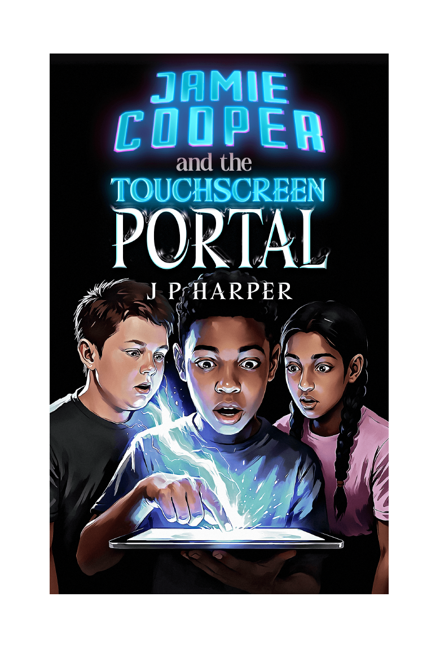
Jamie Cooper and the Touchscreen Portal | The Gateway Saga - Book One | J P Harper

Purpose
This guide helps adults make an informed suitability decision and prepare sensitive readers. It is descriptive rather than prescriptive; individual readers vary widely.

1. Overall tone
The novel combines an emotionally grounded real-world story with an increasingly large fantasy adventure. The opening is quiet and reflective, focusing on Jamie's move, his missing brother and a strained relationship with his father. Suspense grows through unexplained tablet messages before the story expands into magical discovery, friendship, battles and a continuing series mystery.

2. Main themes
Item | Details
Grief and ambiguous loss | Jamie and his father are living with Cameron's unexplained disappearance. The absence shapes their move, silences and difficulty communicating. The story does not resolve Cameron's fate in Book One.
Belonging and starting again | Jamie arrives in a new home and school feeling displaced. Dan and Lakshmi also experience forms of invisibility or misjudgement. Myridiam becomes a place where the trio can recognise their value.
Friendship and found family | Trust develops through small actions, shared secrets, protection and collaborative choices rather than instant closeness.
First impressions and prejudice | Dan is judged by pupils, teachers and circumstances before Jamie knows him. Cultural mistrust also affects encounters between the peoples of Myridiam.
Courage and responsibility | Characters repeatedly decide whether to act despite fear. The book allows discussion of bravery, recklessness, duty, consequences and care for others.
Identity and recognition | The roles Guardian and Protector reflect qualities already present in Dan and Lakshmi. Myridiam gives all three children forms of recognition they do not consistently receive at home.
Technology, games and reality | The Gateway resembles a game system, but the people and consequences of Myridiam resist being treated as unreal. The story raises questions about how moral responsibility changes when a digital environment can suffer.
Power and teamwork | Magical abilities matter, but strategy, empathy, observation, restraint and trust are equally important. Success depends on complementary strengths.

3. Content notes
Item | Details
Missing family member and grief | Frequent emotional references to Cameron, Jamie's missing older brother. Family members do not know whether he is alive.
Family tension | Jamie and his father struggle to speak openly. Financial pressure and emotional exhaustion are present.
Bullying and intimidation | Jamie is cornered and shoved by older pupils. Dan is mocked, isolated and treated unfairly by some pupils and a teacher.
Difficult home environment | Dan's father is shown intoxicated and verbally belittling. Earlier bruises and Dan's guarded behaviour suggest a troubled home life, although explicit physical abuse is not depicted in the supplied manuscript.
Fantasy peril and violence | Monster attacks, weapon use, battles, pursuit and threats to children and civilians. Injuries and blood are mentioned, but descriptions are not graphic.
Fire and destruction | Homes and settlements are attacked and burned. Characters assist wounded people and displaced families.
Abduction and imprisonment | An elderly Khitari cleric is captured and transported by enemy forces.
War themes | Raids develop into the possibility of wider conflict between peoples. The story includes military pursuit, alliances and tactical decisions.
Cliffhanger and unresolved threat | The stolen Heart Stone remains missing, Cameron has not been found, 2126 remains unexplained and the story ends with the next journey delayed.
Language, sex and romance | No sexual content. Romance is not a focus. Strong language is not a notable feature.

4. Discussion approaches for sensitive themes
Grief: Allow readers to speak in general terms rather than disclose personal experiences. Use questions about how silence affects Jamie and his father, and what supportive communication might look like.
Bullying: Focus on power, bystander choices, safe help-seeking and Dan's controlled intervention. Avoid suggesting that a child should physically confront bullies.
Dan's home life: Discuss how harmful words can affect identity and why trusted adults and safeguarding systems matter. Do not require readers to compare the scene with their own home.
Violence and war: Distinguish exciting action from consequences. The aftermath chapters are useful for discussing injury, displacement, care and the limits of victory.
Digital trust: Make clear that Jamie's choice is a fictional plot device, not a model for real online behaviour. Ask how unknown messages should be handled safely in real life.

5. Positive and protective elements
- Friendships grow through loyalty, listening, mutual respect and practical help.
- Characters protect children, civilians and wounded companions.
- Violence is not presented as the only form of courage; restraint, planning, care and persistence are valued.
- The trio learn that their differences make the group stronger.
- Adults and leaders in Myridiam can recognise, support and thank the young characters.
- The story contains humour, wonder, companionship and hope alongside danger.

6. Suitability considerations
Item | Details
Likely comfortable readers | Readers accustomed to middle-grade fantasy adventure, sustained peril and emotionally serious themes.
May need preparation | Readers affected by missing-person stories, bereavement, bullying, parental alcohol misuse, burning homes, war or unresolved endings.
Possible support | Advance notice, paired or shared reading, permission to pause, brief chapter summaries and access to a trusted adult for discussion.
Important limitation | Age labels are only a guide. The best decision depends on the individual reader's experience, confidence and sensitivities.

7. Suggested adult questions
- Is there any theme here that may connect too closely with the reader's current circumstances?
- Would advance notice make a difficult scene manageable without spoiling the story?
- Does the reader prefer to discuss emotional content, write privately or move on without extended discussion?
- Which positive relationships and coping strategies can be highlighted after a difficult scene?
- Is the unresolved ending likely to create productive curiosity or unwanted anxiety for this reader?

8. Suggested content statement for a website or catalogue
Concise content note
Contains themes of grief and a missing family member, school bullying, difficult family relationships, fantasy battles, injuries, abduction, burning settlements and threats of war. Violence is not graphic. No sexual content; romance is not a focus.

