Book Suitability Information Sheet
  - A quick reference for teachers, librarians, home educators and reading-group leaders

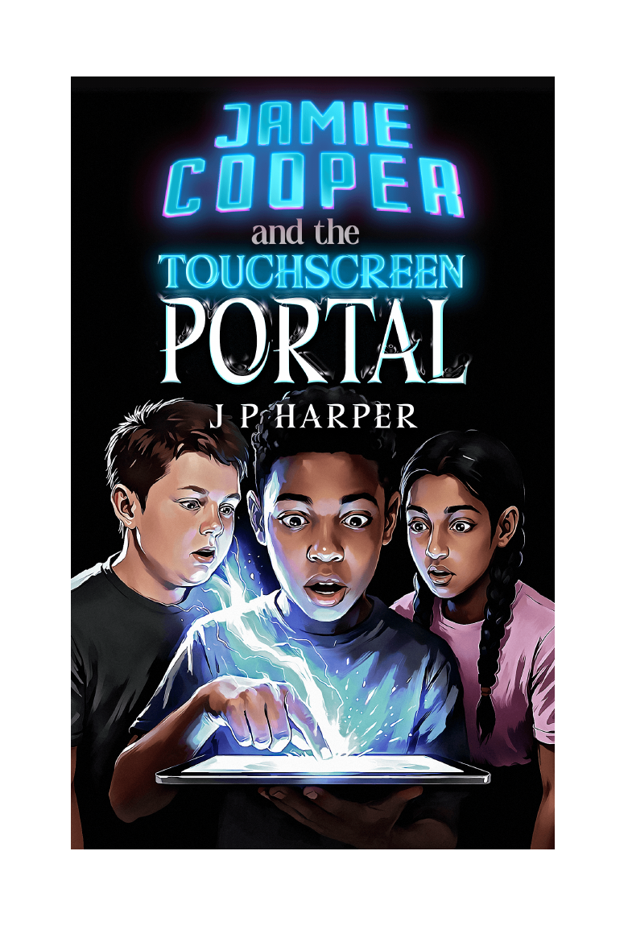
Jamie Cooper and the Touchscreen Portal | The Gateway Saga - Book One | J P Harper

At a glance
A fast-moving portal fantasy and science-fiction adventure for readers who enjoy games, quests, maps, mystery, teamwork and hidden worlds.

Book information
Item | Details
Title | Jamie Cooper and the Touchscreen Portal
Author | J P Harper
Series | The Gateway Saga - Book One
Publisher | Creative-Sparx Press
Publication year | 2026
Genre | Upper middle-grade portal fantasy / science-fiction adventure
Recommended age | 9-14, with suitability depending on reading confidence and sensitivity to peril
Length | 20 chapters; approximately 350 pages, depending on edition
Formats | Ebook, paperback and hardback
ISBN-13 shown in supplied edition | 978-1-0676014-2-3

Spoiler-light premise
Jamie Cooper is trying to cope with a new home, a new school and the disappearance of his older brother. Then his tablet begins displaying impossible messages from the year 2126. When Jamie touches a glowing pattern, he is transported through a Gateway into Myridiam, a world of strange peoples, magical artefacts and dangers that feel far too real to be part of a game. Joined by Dan and Lakshmi, Jamie must decide what courage, friendship and responsibility mean when actions in another world have real consequences.

Reader fit
- Readers who enjoy portals, quests, maps, magical weapons and developing mysteries.
- Young people interested in games or game-like discovery, without the story depending on a real commercial game.
- Readers who like friendship groups in which each character contributes a different strength.
- Readers who appreciate emotional depth alongside action and fantasy adventure.
- Some reluctant readers who respond to clear goals, escalating challenges and a strongly visual world.

Possible settings for use
Item | Details
Independent reading | Suitable for many confident readers aged 9-14.
Class or guided reading | Best used selectively, with chapter groupings, discussion and teacher awareness of sensitive themes.
School or public library | Strong fit for fantasy, science-fiction, portal fantasy, gaming-interest and reluctant-reader displays.
Book clubs | Offers substantial discussion on identity, trust, friendship, risk, grief and moral choices.
Creative-writing study | Useful for portals, suspense, invented worlds, maps, artefacts, cultures and alternative viewpoints.

Themes
- Belonging and starting again
- Grief and family silence
- Friendship and found family
- Courage and responsibility
- First impressions and prejudice
- Trust, secrecy and communication
- Power, teamwork and identity
- Technology, games and reality

Content overview
The novel includes a missing older sibling, grief, family tension, school bullying, an intimidating parent affected by alcohol, fantasy creatures, battles, injuries, burning buildings, abduction and threats of war. Violence and peril are significant but not graphically described. There is no sexual content and romance is not a focus. Adults should consult the separate Content and Themes Guide when choosing the book for particularly sensitive readers.
Adult preview: Opening chapters, the Myridiam map and audio preview links are available at portal.jpharper.com.

