After-Reading Discussion Sheet
  - Whole-book questions, debates and creative responses

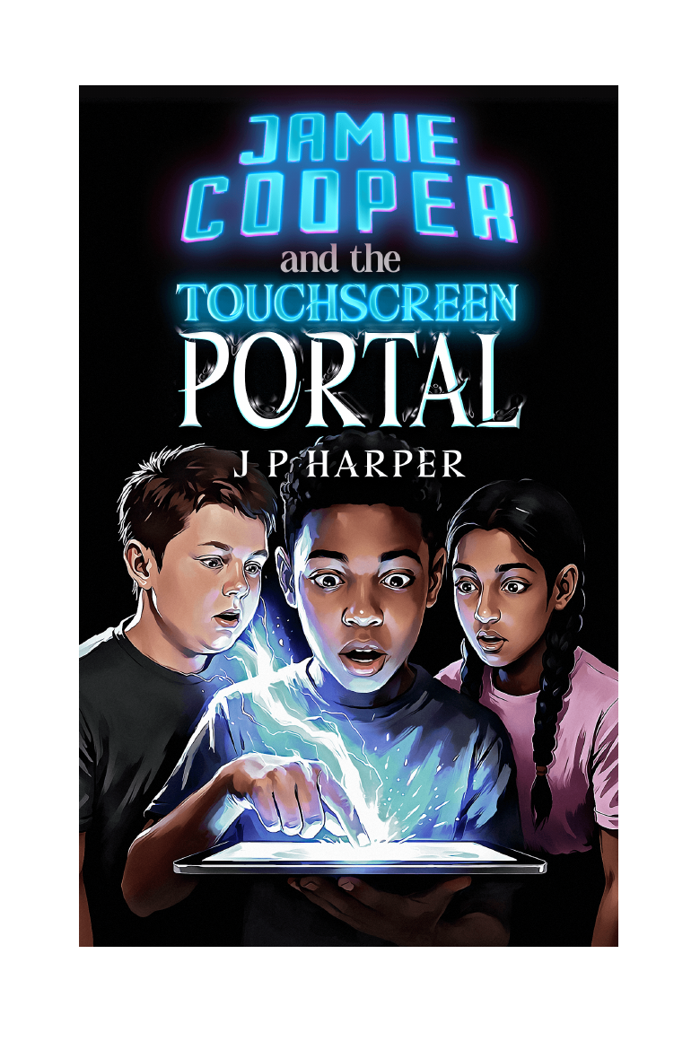
Jamie Cooper and the Touchscreen Portal | The Gateway Saga - Book One | J P Harper

For completed readers
Use the questions selectively. A productive discussion may explore a few prompts in depth rather than attempting every question.

A. Character and change
- How is Jamie different at the end of the book from the boy who arrives at number forty-seven?
- Which character changes most: Jamie, Dan or Lakshmi? Use at least two moments as evidence.
- What does each member of the trio contribute that cannot be replaced by a magical ability?
- Why does Myridiam allow Dan and Lakshmi to see themselves differently?
- Which relationship feels most changed by the end of the novel, and why?

B. Themes and ideas
- What does the novel suggest about first impressions and labels?
- When does secrecy protect a person, and when does it become harmful?
- How does grief influence Jamie's decisions even when Cameron is not being discussed directly?
- Is courage shown mainly through fighting, or through other kinds of action?
- What responsibilities come with power, knowledge and the ability to leave one world for another?

C. Myridiam: game or world?
- What evidence makes Myridiam appear game-like?
- What evidence makes it appear independent and alive?
- Do the labels Guardian and Protector define the characters, or reveal qualities already present?
- Who or what may have created the Gateway system?
- Does it matter whether Myridiam is technically a simulation if its people can suffer and make choices?

D. Moral choices
- Should Jamie have activated the Gateway without telling an adult?
- Was bringing Dan and Lakshmi into Myridiam fair when Jamie did not understand the risks?
- Was dividing the trio the right decision?
- How should the group balance helping Myridiam with responsibilities in their own world?
- At what point should a person stop taking risks, even for a good cause?

E. Debate motions
- Jamie is brave more often than he is reckless.
- Dan is the strongest member of the trio.
- Lakshmi makes the most important decisions.
- The Gateway should be destroyed if the trio ever gains that choice.
- The adults in the real world deserve to know the truth.
- The rescue of Tashen counts as a victory despite the loss of the Heart Stone.

F. Unresolved mysteries
Mystery | Evidence so far | My prediction
Where is Cameron?
Who or what is 2126?
What is the Gateway?
Why are the relics being taken north?
What is at Mount Aggravar?

G. Creative responses
- Write the opening page of Book Two from Cameron's point of view.
- Create an intercepted message from 2126 that reveals one clue but creates two new questions.
- Design a recruitment poster for the coalition travelling north.
- Write a scene in which Jamie tells his father part of the truth.
- Create a diary entry from Sathyra, Trabian, Rebic, Nevic or Tashen.
- Plan a new territory, people or artefact that could appear later in The Gateway Saga.

Final reflection
Complete one of the following statements:
The idea I will remember most is...
________________________________________________________________________________
________________________________________________________________________________
The character I understand differently now is...
________________________________________________________________________________
________________________________________________________________________________
The choice I disagreed with most was...
________________________________________________________________________________
________________________________________________________________________________
The mystery I most want answered is...
________________________________________________________________________________
________________________________________________________________________________

