Chapter Discussion Guide
  - Questions and extension prompts for all twenty chapters

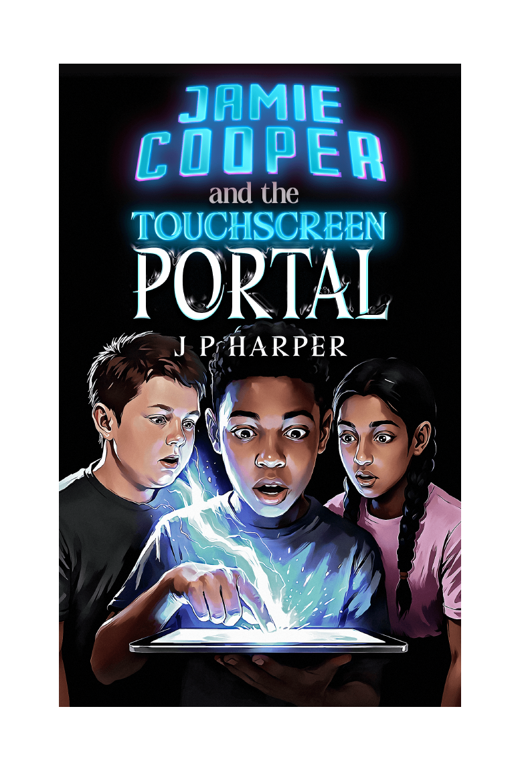
Jamie Cooper and the Touchscreen Portal | The Gateway Saga - Book One | J P Harper

Spoiler warning
This guide discusses events throughout the complete novel. It is intended for adults leading discussion or for readers who have completed each named chapter.

1. The Weight of Silence
1. How does the new house reflect Jamie's emotional state?
2. Why do Jamie and his father avoid speaking directly about Cameron?
3. What is the effect of Cameron's rucksack and the strange circular drawing appearing so early in the story?
Extension: Write one sentence explaining what Jamie wants and one explaining what he fears.

2. First Day, New Shadows
1. Which details make Jamie feel like an outsider at Briarwood Academy?
2. What first impressions does Jamie form of Lakshmi and Dan? Which impressions are based on evidence and which are assumptions?
3. How does the tablet glitch change the mood at the end of the chapter?
Extension: Identify three techniques used to build unease without showing an obvious threat.

3. Echoes in the Wires
1. Why does Jamie try to explain the messages as a technical fault?
2. What should a sensible person do before following instructions from an unknown sender?
3. Is Jamie's decision to touch the pattern brave, reckless, compassionate or curious? Defend one interpretation.
Extension: Rewrite one message from 2126 so that it sounds more trustworthy - or more threatening.

4. The Game
1. How does the Selection Chamber combine fantasy and game-like conventions?
2. Why might the bow be an appropriate artefact for Jamie?
3. Which sensory details persuade Jamie that Myridiam is more than an ordinary game?
Extension: Design an artefact for a character who avoids conflict but still wants to help others.

5. The Khitari in the Trees
1. How do Jamie and Sathyra gradually decide whether to trust one another?
2. What does Sathyra's description of Myridiam reveal about its peoples and tensions?
3. Why is Jamie's promise to return important even though he cannot control the Gateway?
Extension: List the misunderstandings caused by Jamie and Sathyra coming from different worlds.

6. Moments and Hours
1. What evidence suggests Jamie's experience was physical as well as mental?
2. How does the difference between time in Myridiam and time at home create opportunity and danger?
3. What does Jamie's quiet help for Dan in class reveal about him?
Extension: Write a rule that would make the Gateway safer to use.

7. Unlikely Allies
1. Why does Dan choose restraint when confronting the older boys?
2. How does the scene challenge the rumours Jamie has heard about Dan?
3. Why might Jamie use Myridiam as an escape after feeling powerless in the real world?
Extension: Debate: walking away from a fight can require more courage than fighting back.

8. Alone in Myridiam
1. What connects the ancient monument, Jamie's doodles and Cameron's notes?
2. Does Jamie have time to think before protecting the Khitari children? Does that make his action more or less brave?
3. At what point does Jamie begin to accept that events in Myridiam have real consequences?
Extension: Create a short news report from Clearwater describing the rescue of the children.

9. Accidental Truths
1. Why does Dan believe Jamie after seeing the holographic map?
2. What changes when Jamie finally shares his secret with someone else?
3. Why do Jamie and Dan decide that Lakshmi may be important?
Extension: Write the conversation Dan might have with himself before asking to enter Myridiam.

10. New Players
1. How does Lakshmi balance scepticism with curiosity?
2. What do the artefacts and changed clothing suggest about the system that controls entry into Myridiam?
3. Why do the three children run towards the cries even though they are inexperienced?
Extension: Compare the trio's non-magical strengths before discussing their powers.

11. Fire
1. How do Jamie, Dan and Lakshmi contribute differently during the attack on Clearwater?
2. What evidence shows that the Reptoid attack is planned rather than random?
3. Why does the loss of Tashen and the Heart Stone change the conflict from a local attack into a larger threat?
Extension: Hold a council vote: pursue the raiders immediately or remain to defend and recover.

12. Claws, Fangs and Shields
1. How does misunderstanding contribute to conflict between the Khitari group and the Sothians?
2. What do the newly unlocked abilities reveal about the roles of Jamie, Dan and Lakshmi?
3. Why is choosing to return home and rest a responsible decision rather than a retreat?
Extension: Create a teamwork diagram showing how one character's ability supports another.

13. Exit Strategy
1. How does ordinary life feel different after the trio return from Myridiam?
2. What might 2126 be monitoring, and why does one-way communication matter?
3. How do the friends use observation and planning rather than simply reacting?
Extension: Write three possible explanations for 2126 and rank them from most to least convincing.

14. Diverging Priorities
1. What advantages and risks come from entering the Gateway separately?
2. Why does the group decide to divide its efforts?
3. What is the difference between risking separation and choosing to help more people?
Extension: Create a decision tree showing the consequences of staying together or splitting up.

15. The Town of Stone and Smoke
1. How has Jamie's view of himself changed since the beginning of the novel?
2. What earns Jamie the trust of Trabian and the Sothian defenders?
3. How does Oakhill show the effects of conflict on ordinary people rather than only warriors?
Extension: Write a short reflection beginning: "I am not helpless because..."

16. Through the Broken Pass
1. How do Dan and Lakshmi respond differently to uncertainty and danger?
2. Which clues suggest the pursuit may be leading into a trap?
3. Why does the group continue even when caution tells them to turn back?
Extension: Draw the pass as a tactical map and mark places of danger, protection and escape.

17. The Champion of the Ravine
1. What does Dan mean when he calls himself the Guardian?
2. How do endurance, strategy and teamwork matter more than raw power in the battle?
3. Why is the mysterious symbol on the defeated champion more troubling than an ordinary enemy mark?
Extension: Debate whether Dan's refusal to break is strength, stubbornness or both.

18. Lines Converge
1. How does the arrival of different groups turn former strangers into allies?
2. Why is rescuing Tashen a victory even though the Heart Stone remains lost?
3. What does the empty satchel reveal about assumptions, evidence and deception?
Extension: Rewrite the discovery of the empty satchel from Nevic's point of view.

19. After the Storm
1. Why must the group care for the wounded before continuing the chase?
2. How has the relationship between Khitari and Sothians changed?
3. What makes Mount Aggravar an effective focus for the next stage of the story?
Extension: Create a briefing note listing what the coalition knows, suspects and still needs to discover.

20. Between Worlds
1. How do Dan, Lakshmi and Jamie each feel more valued in Myridiam than at home?
2. What do Dan's father and Lakshmi's family scenes add to our understanding of their choices?
3. Why is Jamie missing the planned return significant even though it is an ordinary mistake?
4. Which unresolved mystery most strongly encourages the reader to continue the series?
Extension: Write a message Jamie should send to Dan and Lakshmi that takes responsibility without making excuses.

