Before-Reading Activity Sheet
  - Prediction, genre, digital-safety and worldbuilding tasks

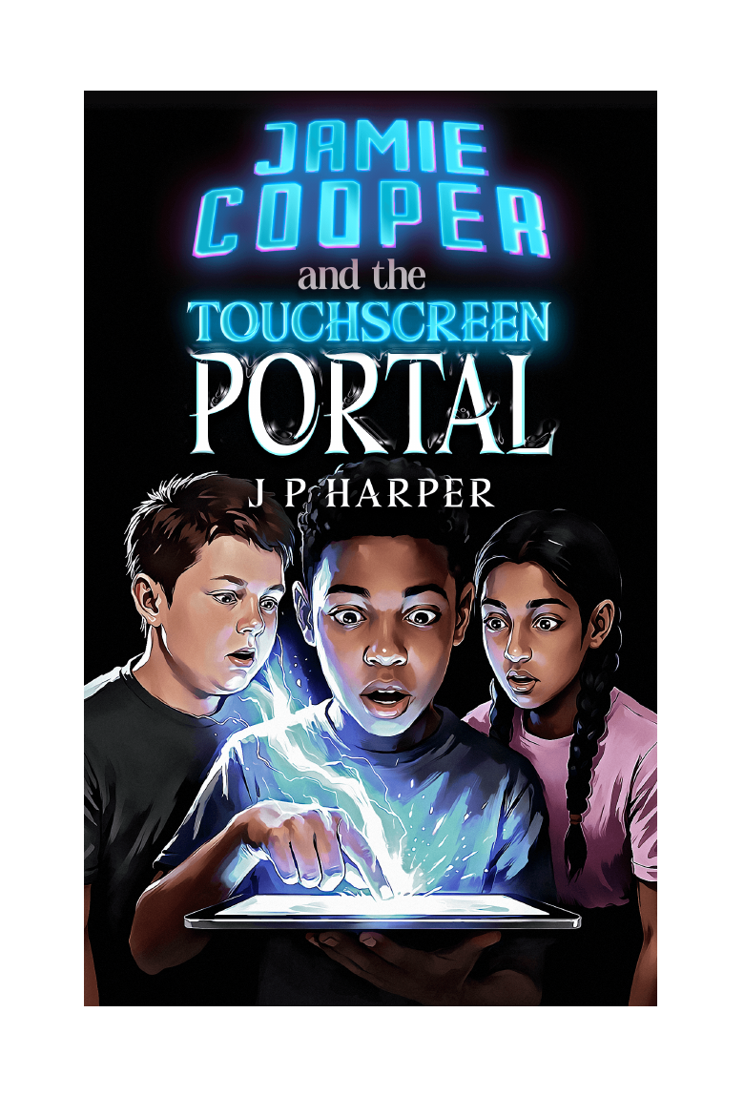
Jamie Cooper and the Touchscreen Portal | The Gateway Saga - Book One | J P Harper

For readers
Complete these activities before beginning the novel. There are no wrong predictions - the purpose is to notice clues, ask questions and explain your thinking.

Activity 1 - First impressions
Study the title and cover. Record what each element suggests.
Element | What it suggests
The tablet
The three characters
The light and colour
The word "Portal"
My three predictions:
1. ________________________________________________________________________________
2. ________________________________________________________________________________
3. ________________________________________________________________________________
One question I want the story to answer:
________________________________________________________________________________
________________________________________________________________________________

Activity 2 - What is portal fantasy?
A portal story connects an ordinary world with another place. Complete the planning grid for an imaginary portal story of your own.
The ordinary setting
The portal or gateway
How it is activated
The new world
One rule of the new world
A danger
A reason to return home

Activity 3 - Would you trust the message?
Imagine that your tablet displays these messages from an unknown sender:
SYSTEM ALERT
Connection established. Gateway unstable. You are needed. Touch the pattern when it appears.

Circle or highlight your first response:
IGNORE IT | INVESTIGATE FIRST | FOLLOW THE INSTRUCTION
Give two reasons for your choice:
________________________________________________________________________________
________________________________________________________________________________
________________________________________________________________________________
________________________________________________________________________________
What evidence would make the message more trustworthy?
________________________________________________________________________________
________________________________________________________________________________
________________________________________________________________________________
What warning signs would make it less trustworthy?
________________________________________________________________________________
________________________________________________________________________________
________________________________________________________________________________

Activity 4 - Map detective
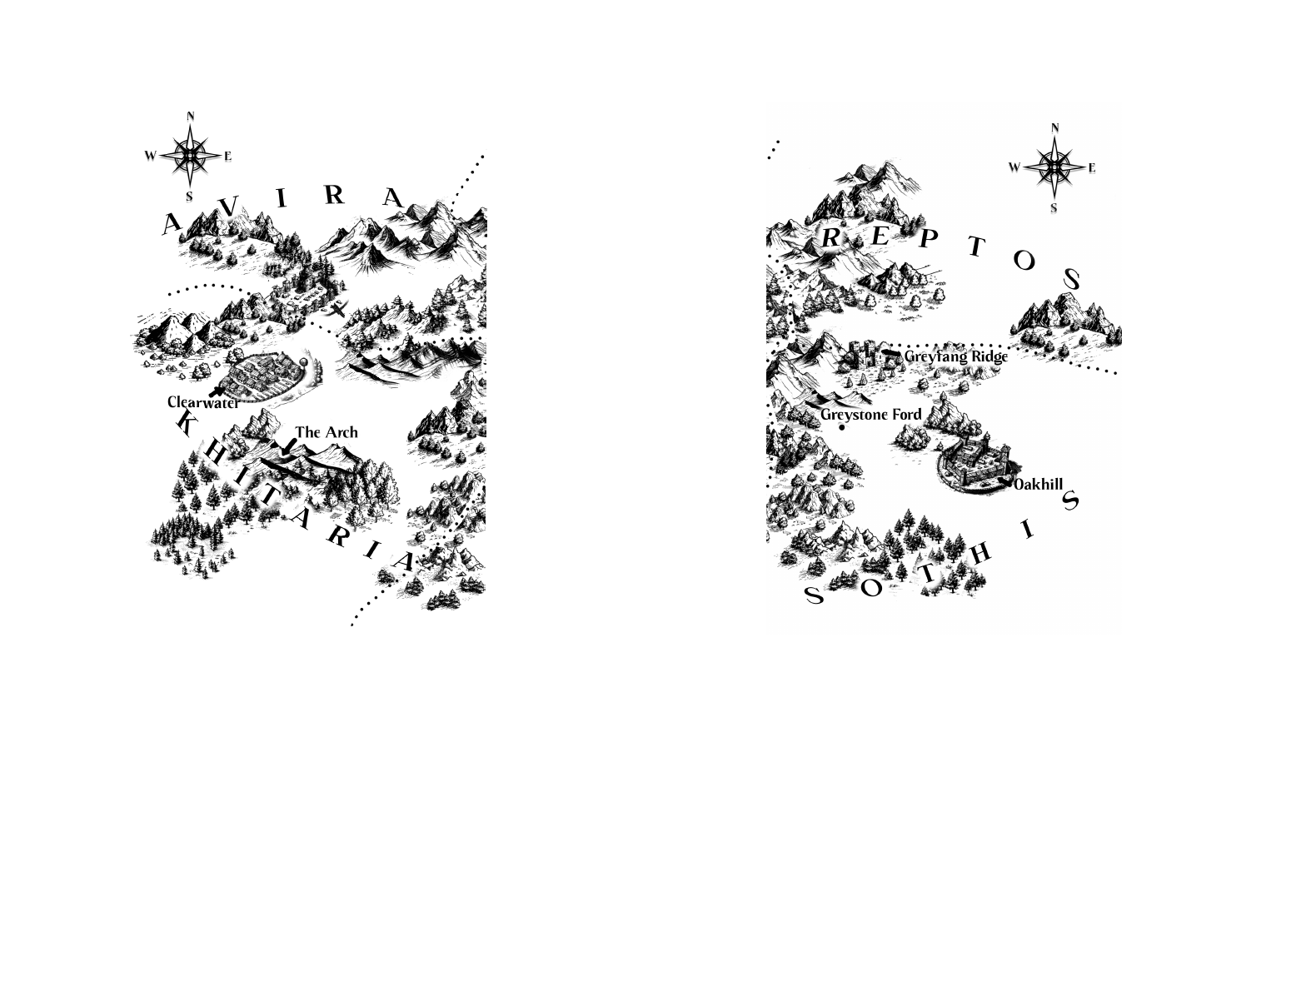
Which place name interests you most, and why?
________________________________________________________________________________
________________________________________________________________________________
Where might a traveller find shelter?
________________________________________________________________________________
________________________________________________________________________________
Which route appears most dangerous?
________________________________________________________________________________
________________________________________________________________________________
What natural features may separate different peoples or territories?
________________________________________________________________________________
________________________________________________________________________________

Activity 5 - A difficult choice
A character believes that someone may genuinely need help, but the request could also be a trap. Complete the balance below.
Reasons to act | Reasons to wait or refuse
My final decision and explanation:
________________________________________________________________________________
________________________________________________________________________________
________________________________________________________________________________
________________________________________________________________________________

Teacher note
Revisit Activities 1, 3 and 5 after Chapter Three. Ask readers which predictions have changed, whether Jamie has enough evidence to act, and whether curiosity, compassion or risk is driving his decision.

