Teacher and Educator Guide
  - Teaching ideas, discussion pathways and cross-curricular activities for readers aged 9-14

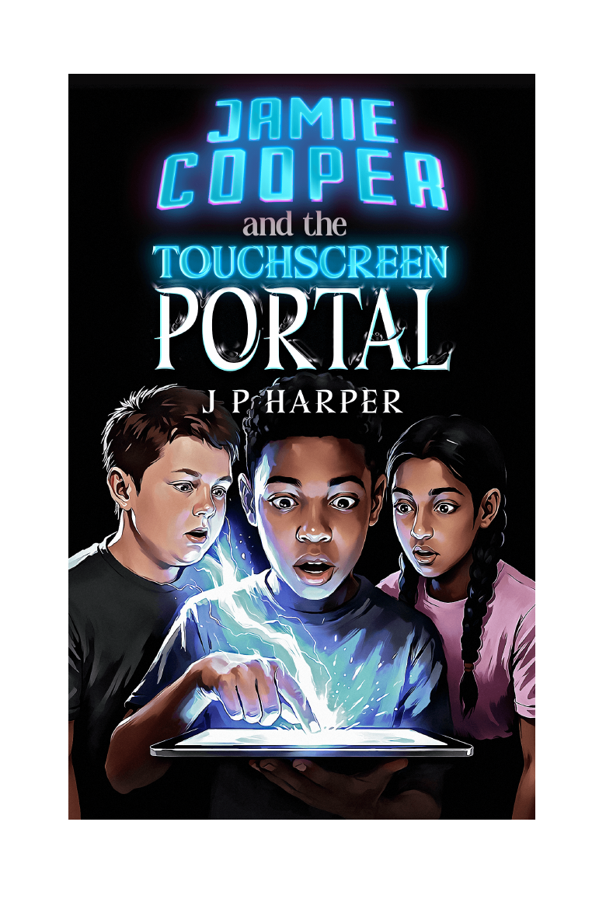
Jamie Cooper and the Touchscreen Portal | The Gateway Saga - Book One | J P Harper

Purpose of this guide
This guide supports whole-class, small-group, book-club and independent reading. Activities can be selected individually; there is no requirement to complete every section.

1. Quick guide to the book
Item | Details
Title | Jamie Cooper and the Touchscreen Portal
Author | J P Harper
Series | The Gateway Saga - Book One
Genre | Upper middle-grade portal fantasy with science-fiction and game-like elements
Recommended readers | Ages 9-14; suitable for confident upper-primary readers and many lower-secondary readers
Structure | 20 chapters; approximately 350 pages, depending on edition
Central premise | A twelve-year-old boy receives impossible messages through his tablet and discovers a Gateway into Myridiam, a world that may be far more real than a game.
Key themes | Belonging, grief, friendship, courage, trust, responsibility, identity, first impressions and found family
Possible curriculum links | English, PSHE/personal development, computing and digital literacy, geography, art and design, drama

2. Learning opportunities
- Retrieve information and make inferences using evidence from the text.
- Analyse characterisation, point of view, setting, suspense and pacing.
- Explore how first impressions and social labels influence behaviour.
- Discuss ethical decisions involving danger, trust, secrecy and responsibility.
- Compare game-like conventions with consequences in a living fictional world.
- Develop creative writing through portals, artefacts, maps, invented cultures and alternative viewpoints.
- Practise collaborative discussion, debate, presentation and reflective writing.

3. Suggested reading structures
Item | Details
Five-part reading plan | Chapters 1-4, 5-8, 9-12, 13-16 and 17-20. Useful for a five-week book club or guided-reading sequence.
Ten-session plan | Read two chapters per session, followed by one discussion question and one short activity.
Independent reading | Use the chapter checkpoints, character tracker and prediction journal as light-touch support.
Read-aloud extract approach | Select high-interest scenes - the tablet messages, Selection Chamber, first meeting with Sathyra, Clearwater attack and ravine confrontation - while pupils read the remainder independently.

4. Before-reading activities

Title and cover predictions
Purpose | Activate prior knowledge and establish a purpose for reading.
Instructions | Show the title and cover without revealing the blurb. Ask readers to identify details suggesting ordinary life, technology, danger and fantasy. Record three predictions and one question.

Would you touch the pattern?
Purpose | Introduce ethical choice and risk assessment.
Instructions | Present the situation: an unknown device says, "You are needed." Readers decide whether to respond and list evidence they would need before acting.
Extension: Repeat the vote after Chapter Three and compare how the evidence changes opinions.

Portal fantasy expectations
Purpose | Build genre awareness.
Instructions | Create a class list of features expected in a portal story: an ordinary world, a threshold, an unfamiliar world, rules, allies, dangers and a reason to return.

5. During-reading discussion pathways
Belonging and identity: Track when Jamie, Dan and Lakshmi feel unseen or misjudged in the real world, and how their identities change in Myridiam.
Truth and secrecy: Identify what Jamie hides, why he hides it, and when secrecy protects or harms relationships.
Courage and responsibility: Distinguish bravery from impulsiveness. Ask what each character risks and who may be affected by the decision.
Is Myridiam a game?: Collect evidence for and against the idea that Myridiam is a programmed world. Revise the conclusion as new evidence appears.
Power and teamwork: Record each character's abilities, limitations and non-magical strengths. Consider why no single character can solve every problem.

6. Cross-curricular activity menu

English - write an impossible message
Purpose | Voice, suspense and concise writing.
Instructions | Write a sequence of no more than six messages from an unknown sender. Each message should reveal something new while raising a larger question.
Extension: Rewrite the sequence from the sender's point of view.

Geography - map a journey
Purpose | Route planning, physical geography and explanation.
Instructions | Use the Myridiam map to plan a route between two named locations. Identify terrain, likely hazards, stopping points and reasons for the chosen route.

The supplied manuscript map of Myridiam may be used as the basis for route-planning and worldbuilding tasks.

Computing and digital literacy - can the message be trusted?
Purpose | Risk assessment, verification and safe decision-making.
Instructions | Create a checklist Jamie should use before following instructions from an unknown system. Separate actions that verify information from actions that merely feel reassuring.

Art and design - create a chosen artefact
Purpose | Visual communication and symbolic design.
Instructions | Design an artefact from the Selection Chamber. Explain its appearance, power, limitation, ideal bearer and the personal quality it represents.

Drama - the council decision
Purpose | Speaking, listening and perspective-taking.
Instructions | Stage a council meeting after the attack on Clearwater. Roles may include Jamie, Sathyra, a wounded defender, a cautious elder, a parent and a young warrior. Decide whether to pursue the raiders or remain to defend the village.

7. Differentiation and access
Item | Details
Support | Use paired reading, audio support, chapter summaries, a character/location tracker and fewer questions with sentence starters.
Core | Ask readers to answer using a point, evidence and explanation structure.
Stretch | Require comparison across chapters, evaluation of author choices and alternative interpretations supported by evidence.
Reluctant readers | Frame progress as short quests, use the map frequently and prioritise prediction, discussion and choice over long written responses.

8. Assessment and final outcomes
- A character evidence portfolio showing how one character changes.
- A persuasive speech arguing whether Jamie should continue using the Gateway.
- A worldbuilding dossier for a new territory of Myridiam.
- A balanced review written for a school library audience.
- A group presentation explaining whether Myridiam should be treated as a game, a world or something else.
- A storyboard or dramatic script adapting one chapter for screen or stage.

9. Sensitive-content guidance
The story contains grief connected to a missing older brother, strained family communication, school bullying, an intimidating parent affected by alcohol, fantasy battles, injuries, burning buildings, abduction and threats of war. Violence is adventurous rather than graphic, but some readers may benefit from advance notice. See the separate Content and Themes Guide for fuller guidance.

10. Further resources
- Before-Reading Activity Sheet
- Chapter Discussion Guide
- After-Reading Discussion Sheet
- Book Suitability Information Sheet
- Content and Themes Guide
- Gateway Preview Pack for adults: portal.jpharper.com

